
CSA15 – CLOUD COMPUTING AND BIG DATA ANALYTICS

ASSIGNMENT 1 – CO1
Design, Analyse and Validate a Cloud-Based Solution for Migrating a Legacy University Management System
CO1: Apply cloud computing technologies including hardware–software evolution, virtualization, web services, and service models to develop cloud-based solutions.

Field | Details | Field | Details
Student Name | P.B.VAMSI KRISHNA | Register Number | 192525147
Department / Section | AI & ML | Academic Year / Semester
Faculty Name | Dr R.Latha | Nature of Assignment | Individual
Duration | 1 Week | Total Marks | 50
Submission Date |  | Evaluation Date

MARK SHEET (Rubric-based evaluation)
Task | Title | Max | Awarded | Evidence / evaluation focus
1 | Introduce Cloud Computing | 3 |  | Definition; characteristics; deployment models; scenario mapping
2 | Trace Evolution and Hardware Evolution | 3 |  | Timeline; hardware evolution; relevance to university
3 | Analyse Internet Software Evolution | 3 |  | Web/software evolution; SOA; APIs; scenario relevance
4 | Apply Server Virtualization | 5 |  | Hypervisor types; VM/container comparison; consolidation; limitations
5 | Apply Web Services | 4 |  | SOA and SOAP/REST; three university APIs; request/response examples
6 | Analyse IaaS, PaaS and SaaS | 5 |  | Responsibility layers; five-application mapping; comparison; providers
7 | Examine XaaS | 3 |  | Four or more variants; two justified choices; provider risks
8 | Design Cloud Solution Architecture | 5 |  | Labelled diagram; deployment/service models; scaling; security; DR
9 | Hands-on Implementation and Documentation | 4 |  | Running VM/container; PaaS/SaaS; tests; actual screenshots
10 | Evaluate and Recommend Final Solution | 7 |  | Three-way comparison; 3-year costs; risks; phased roadmap
11 | Day-4 Design Challenge | 8 |  | Impact; evaluation; adaptation; evidence-based defence
 | TOTAL | 50 |  | Percentage :

EVIDENCE VERIFICATION CHECKLIST

Tasks | Evidence expected | Status (✓ / P / ✗) | Evaluator note
1–3 | Conceptual explanations, comparisons and relevant illustrations | ✓ | Explanations and relevant scenario mapping documented
4 | Virtualization calculations with stated assumptions and peak-load caution | ✓ | Calculations present; practical capacity validation recommended
5–7 | API examples, service responsibility table and justified XaaS choices | ✓ | Required conceptual evidence documented
8 | Labelled architecture diagram, caption below figure and component justification | ✓ | Architecture documented; sizing assumptions need testing
9 | Actual code, environment details, execution logs, API outputs and screenshots | P | Procedures provided; actual execution evidence not established
10 | Cost assumptions, 3-year totals, risk controls and migration roadmap | ✓ | Estimates and rationale documented
11 | Day-4 changes, 10× load strategy, 99.9% target and 40-college isolation | ✓ | Design analysis documented; practical validation pending

IMPLEMENTATION EVIDENCE CHAIN

Evidence item | Status | Observation
Source code | ✓ | Flask REST API and Dockerfile provided in the proposed implementation
Virtualization | P | Docker container configuration documented; running-container evidence required
PaaS or SaaS | P | Managed web-service deployment procedure described; live deployment not verified
Functional test | P | Expected HTTP 200 response and JSON output documented; actual output required
Failure case | P | HTTP 404 test case documented; actual execution record required
Screenshots | P | Screenshot requirements identified; authentic screenshots need verification
Reproducibility | ✓ | Build commands, run commands, endpoints and expected results specified

OVERALL REMARKS

__p.b.vamsi_____________  Student Signature | _______________  Faculty Signature | _______________  Program Director
MANDATORY SUBMISSION EVIDENCE CHECK
✓ = Present in documented answer; P = Partly present; ✗ = Missing / not satisfied
Task | Evidence expected | Status | Evaluator note
1 | Cloud definition, characteristics, deployment models and scenario mapping | ✓ | All conceptual requirements covered
2 | Evolution timeline, hardware development and university relevance | ✓ | Well explained with relevant examples
3 | Internet software evolution, SOA and APIs | ✓ | Clear explanation and scenario relevance
4 | Hypervisors, VM/container comparison and consolidation calculations | ✓ | Calculations included; peak-load limitations discussed
5 | SOAP/REST comparison and three university APIs | ✓ | API methods and request/response examples documented
6 | IaaS/PaaS/SaaS responsibility layers and application mapping | ✓ | All five applications categorized with justification
7 | XaaS variants and two justified selections | ✓ | Six variants explained; DBaaS and DRaaS recommended
8 | Labelled architecture, scaling, security and disaster recovery | ✓ | Design and component justifications documented
9 | Working container, PaaS/SaaS deployment, actual tests and screenshots | P | Code and procedures provided; actual execution evidence requires verification
10 | Three-year cost comparison, risks and migration roadmap | ✓ | Cost assumptions, calculations and recommendations included
11 | Impact analysis, 10× load, 99.9% availability and tenant isolation | ✓ | Changed requirements evaluated; load-test evidence recommended

IMPLEMENTATION EVIDENCE CHAIN
Evidence item | Status | Observation
Source code | ✓ | Python Flask REST API and Dockerfile documented
Virtualization | P | Docker build and run procedures provided; execution screenshot required
PaaS or SaaS | P | Cloud deployment steps described; actual deployment confirmation required
Functional test | P | HTTP 200 and expected JSON response documented; actual test output required
Failure case | P | HTTP 404 test case included; execution evidence required
Screenshots | P | Required screenshots identified but authenticity and completeness not verified
Reproducibility | ✓ | Installation, configuration, commands and testing steps documented
Interpretation | ✓ | Technical outcomes and implementation limitations explained
Code and report consistency | ✓ | Proposed API, Docker configuration and testing procedure are aligned

SUBMISSION CHECKLIST (Not Separately Marked)
Requirement | Status
All 11 tasks answered | ☒ Yes ☐ Partly ☐ No
Cloud concepts and comparisons explained | ☒ Yes ☐ Partly ☐ No
Virtualization calculations included | ☒ Yes ☐ Partly ☐ No
API examples and service models explained | ☒ Yes ☐ Partly ☐ No
Cloud architecture diagram included | ☒ Yes ☐ Partly ☐ No
Implementation and testing evidence provided | ☐ Yes ☒ Partly ☐ No
Three-year cost analysis and roadmap included | ☒ Yes ☐ Partly ☐ No
Day-4 design challenge completed | ☒ Yes ☐ Partly ☐ No
Figures and screenshots included | ☐ Yes ☒ Partly ☐ No
Table and figure numbering correct | ☐ Yes ☒ Partly ☐ No
Viva recommended | ☒ Yes ☐ No

CSA15 – Cloud Computing and Big Data Analytics
ASSIGNMENT 1
CO1: Apply cloud computing technologies including hardware–software evolution, virtualization, web services, and service models to develop cloud-based solutions.

Assignment Title: Design, Analyse and Validate a Cloud-Based Solution for Migrating a Legacy University Management System (Total Marks – 50)
Duration: 1 week
Scenario – Smart Campus Cloud Migration
A multi-campus university currently runs its Student Information System, Learning Management System, Library System, Exam Portal and Email on ageing physical servers in a single on-premise data centre. Each application has its own dedicated server, which stays idle for most of the year but fails to cope during admissions, result publication and online-exam weeks.
The university's current environment is:
- 12 physical servers, average CPU utilisation of about 15%, with peaks above 95% during admissions and exams
- Approximately 25,000 students and 2,000 staff across 4 campuses
- Applications built as large monolithic programs, with no public interfaces for mobile apps or partner colleges
- High capital expenditure, slow procurement (6–8 weeks per server) and no disaster recovery site
As a cloud consultant, you must study how computing evolved to the cloud model, and then design a cloud-based solution that uses virtualization, web services and an appropriate mix of service models (IaaS, PaaS, SaaS and XaaS) for the university. All recommendations must be justified in terms of cost, scalability, availability and manageability.
Design Challenge:
On Day 4, the university announces that it will launch a mobile app and open student-record and fee-payment services to 40 affiliated colleges. Expected load is 10 times the current peak, with a requirement of 99.9% availability and a limited operating budget. Re-evaluate your original design and decide whether it should be retained, modified or redesigned.
TASK 1 – Introduce Cloud Computing and Map It to the Scenario (3 Marks)
Design and Propose cloud computing model for the context of the university's problems.
- Definition of cloud computing and the five essential characteristics (on-demand self-service, broad network access, resource pooling, rapid elasticity, measured service)
- Deployment models (public, private, hybrid, community) and which one suits the university
- Three problems of the current on-premise setup and how each cloud characteristic addresses them
- Benefits and limitations of cloud adoption for the university
Evidence Expected
A clear explanation of cloud characteristics and deployment models, mapped to the university's actual problems.
TASK 2 – Trace the Evolution and Hardware Evolution (3 Marks)
Trace how computing infrastructure evolved to make cloud computing possible.
- A timeline from mainframes, minicomputers and PCs, to client–server, clusters, grid computing, utility computing and cloud
- Hardware evolution: multi-core processors, commodity servers, high-capacity storage, high-speed networking and data centres
- How each stage solved a limitation of the previous one
- Which stage the university's current system corresponds to, with reasons
Evidence Expected
A labelled timeline or diagram, with a justified explanation of how hardware advances enabled the cloud.
TASK 3 – Analyse Internet Software Evolution (3 Marks)
Explain how internet software evolved and why it supports cloud services.
- Evolution from static web pages to dynamic web, Web 2.0, SOA, mashups and cloud-hosted applications
- Role of browsers, HTTP, AJAX and APIs in delivering software over the internet
- Comparison between desktop software, client–server software and web-delivered software
- How this evolution affects the design of the university's applications
Evidence Expected
A comparative explanation of software evolution stages, linked to the university's application design.
TASK 4 – Apply Server Virtualization (5 Marks)
Apply server virtualization to consolidate the university's 12 physical servers.
- Explain how a hypervisor works, and distinguish Type-1 and Type-2 hypervisors, with examples
- Compare full virtualization, para-virtualization, OS-level virtualization (containers) and hardware-assisted virtualization
- Propose which applications should run as virtual machines and which as containers, with reasons
- Calculate the consolidation: with an average utilisation of 15% per server and a target host utilisation of 70%, estimate how many physical hosts are needed (show your assumptions and working)
- Discuss live migration, snapshots and resource over-commitment as benefits, and the risks of virtualization (noisy neighbour, hypervisor failure, security isolation)
Show your calculation. A final number without working will not receive full credit.
Evidence Expected
A justified virtualization plan with a worked consolidation calculation and discussion of benefits and risks.
TASK 5 – Apply Web Services (4 Marks)
Analyse web services to expose the university's functions to other systems.
- Overview of web services and their role in cloud and SOA
- Compare SOAP, WSDL, UDDI and RESTful services (HTTP methods, JSON/XML)
- Identify at least three university functions to expose as web services (for example, result lookup, fee payment, library search) and define the endpoint, method and sample request/response for each
- Justify whether SOAP or REST is more suitable for each function
Evidence Expected
A defined set of web services with sample request/response formats and a justified choice of SOAP or REST
TASK 6 – Analyse the Service Models: IaaS, PaaS and SaaS (5 Marks)
Analyse which service model fits each university application.
- Define IaaS, PaaS and SaaS, and show who manages which layer (hardware to application) in each model
- Categorise the five university applications (SIS, LMS, Library, Exam Portal, Email) into IaaS, PaaS or SaaS, with reasons
- Compare the models on control, cost, scalability, maintenance effort and vendor lock-in
- Give one real provider example for each model
Present your categorisation in a table, but explain the reasoning behind each decision. A table alone is not sufficient.
Evidence Expected
A reasoned mapping of applications to service models, supported by a layer-wise responsibility comparison.
TASK 7 – Examine XaaS (3 Marks)
Examine the broader XaaS (Anything-as-a-Service) concept for the university.
- Explain XaaS and describe at least four variants (for example DaaS, BaaS/MBaaS, FaaS, DBaaS, Security-as-a-Service, Disaster-Recovery-as-a-Service)
- Select two XaaS offerings that would benefit the university, and justify them
- Discuss the risks of over-reliance on multiple 'as-a-Service' providers
Evidence Expected
An analysis of XaaS variants, with justified selection of two offerings for the university.
TASK 8 – Design the Cloud Solution Architecture (5 Marks)
Bloom's Level: Level 6 – Create | Action verbs: Design, Construct, Propose
Create a complete cloud architecture for the university by combining virtualization, web services and service models.
- An architecture diagram showing users, load balancer, web/application tier, database tier, storage, API layer and DR region
- The deployment model and the service model chosen for each component
- How elasticity (auto-scaling) will handle admissions and exam peaks
- Basic security and availability measures (access control, encryption, backup, multi-zone deployment)
Evidence Expected
A labelled architecture diagram with written justification for each component and design decision.
TASK 9 – Hands-on Implementation and Documentation (4 Marks)
Implement a small proof-of-concept of your design using a free-tier cloud account or a local virtualization tool.
- Create a virtual machine or container (using AWS/Azure/GCP free tier, VirtualBox, or Docker) and host a simple web page or REST API for one university function
- Deploy a SaaS or PaaS component (for example a cloud-hosted database, a serverless function or a static site)
- Test the web service with a client (browser, Postman or curl) and record the output
- Provide screenshots, configuration steps and any issues faced
Evidence Expected
Annotated screenshots and clear, reproducible steps showing that the proof-of-concept works.
TASK 10 – Evaluate and Recommend the Final Solution (7 Marks)
Evaluate your design and recommend the final cloud solution for the university.
- Compare on-premise, IaaS-based and PaaS/SaaS-based options on cost (CapEx vs OpEx), scalability, availability, security and effort
- Estimate a simple 3-year cost comparison using stated assumptions
- Identify the main risks (vendor lock-in, data privacy, downtime, skills gap) and give mitigation steps
- Provide your final recommendation and a short migration roadmap (which application moves first, and why)
Your recommendation must be supported by the analysis in the previous tasks. Choosing a popular cloud provider without justification is not sufficient.
Evidence Expected
A technically justified recommendation, supported by a cost comparison, risk analysis and migration roadmap.
DAY-4 DESIGN CHALLENGE
TASK 11 – Re-evaluate and Adapt the Design (8 Marks)
Changed Requirement
The university will now launch a mobile app and open student-record and fee-payment services to 40 affiliated colleges. Expected load is 10 times the current peak, availability must be 99.9%, and the operating budget is limited.
Re-evaluate your original design in response to these changed conditions. You may:
RETAIN → MODIFY → or REDESIGN
your original solution.
Impact Analysis – 2 Marks
Discuss:
- What has changed from the original problem
- Which original assumptions (load, users, availability, cost) are affected
- Why the web services and APIs now become critical
- How multi-tenant access by 40 colleges affects security and isolation
Evidence Expected: A clear analysis of how the changed requirements affect the original cloud design.
Evaluation of the Original Design – 2 Marks
Discuss:
- Whether the chosen service models and virtualization plan can handle a 10x load
- Whether auto-scaling and the single-region deployment are sufficient for 99.9% availability (about 8.76 hours of downtime allowed per year)
- Whether cost remains acceptable under the new load
- Whether another service model or XaaS offering would give better overall results
Evidence Expected: A technically supported evaluation of the original design under the new conditions.
Adaptation or Redesign – 2 Marks
Discuss:
- Decide whether to retain, modify or redesign the solution
- Describe the revised architecture (for example API gateway, container orchestration, serverless components, multi-zone deployment or a hybrid model)
- Explain what changed in the service model mix and in the virtualization approach
- If you retain the original design, give sufficient technical justification for why no change is required
Evidence Expected: An appropriate design response to the changed requirement, with clear technical reasoning.
Evidence-Based Defence – 2 Marks
Discuss:
- Capacity and availability calculations
- Cost comparison between the original and the revised design
- Security and multi-tenancy considerations
- Trade-offs such as vendor lock-in, complexity and migration effort
Evidence Expected: A well-supported final decision that follows logically from the analysis.
MARK DISTRIBUTION
Task | Title | Bloom's Level | Marks
Task 1 | Cloud Computing – Introduction & Characteristics | L2 – Understand | 3
Task 2 | Evolution & Hardware Evolution | L2 – Understand | 3
Task 3 | Internet Software Evolution | L2 – Understand | 3
Task 4 | Server Virtualization | L3 – Apply | 5
Task 5 | Web Services | L3 – Apply | 4
Task 6 | Service Models: IaaS, PaaS, SaaS | L4 – Analyze | 5
Task 7 | XaaS | L4 – Analyze | 3
Task 8 | Design the Cloud Solution Architecture | L6 – Create | 5
Task 9 | Hands-on Implementation & Documentation | L3 – Apply | 4
Task 10 | Evaluate & Recommend the Final Solution | L5 – Evaluate | 7
 | Subtotal

Task 11 | Day-4 Design Challenge | L4 / L5 / L6 | 8
 | TOTAL |  | 50

TASK 1 – INTRODUCE CLOUD COMPUTING AND MAP IT TO THE SCENARIO (3 MARKS)
Further explanation: In this university, demand is not constant throughout the academic year. Admissions, fee deadlines and result publication create short periods of unusually high traffic, while servers remain lightly used during ordinary weeks. Cloud computing is suitable because it changes capacity from a fixed asset that must be purchased in advance into a service that can be provisioned according to measured demand. The university should still define who can create resources, what data may be stored in each environment and how costs are approved. Cloud adoption is therefore both a technology change and a governance change.

1.1 Definition
Cloud computing is a model for providing convenient, on-demand network access to a shared pool of configurable computing resources—such as servers, storage, networks, applications and services—that can be rapidly provisioned and released with minimal management effort or service-provider interaction.

1.2 Five essential characteristics
Characteristic | Meaning | Application to this university
On-demand self-service | Users or administrators provision resources when required without waiting for manual provider action. | Create temporary application capacity for admission and result-publication periods.
Broad network access | Services are available over networks through standard mechanisms and different client devices. | Students and staff access portals from campus, home and mobile devices.
Resource pooling | Provider resources serve multiple customers using a multi-tenant model, with resources dynamically assigned. | Combine workloads instead of keeping 12 lightly used dedicated servers.
Rapid elasticity | Capacity can expand or contract quickly with demand. | Add application instances during online examinations and remove them afterwards.
Measured service | Usage is monitored, controlled and metered. | Track compute, storage and network use to control operating cost.

1.3 Deployment models
Model | Description | Suitability
Public cloud | Infrastructure owned by a provider and delivered to customers over the internet or private links. | Good for elastic web tiers, API services, object storage and managed databases.
Private cloud | Cloud environment dedicated to one organisation. | Useful where legacy systems or strict institutional controls require dedicated governance; costs more to operate.
Hybrid cloud | Combination of private/on-premise resources and public cloud with integration between them. | Best fit during phased migration: retain selected legacy workloads while moving elastic services to public cloud.
Community cloud | Shared by organisations with common requirements, such as a group of educational institutions. | Could support shared services for affiliated colleges if governance and data ownership are agreed.

Recommended deployment: HYBRID CLOUD during migration, with a public-cloud-first target for scalable, non-legacy services. Sensitive records remain protected through encryption, role-based access, private connectivity and approved data-residency controls. A private environment is retained only where a documented compliance or technical requirement justifies it.

1.4 Current problems and cloud mapping
Current problem | Relevant cloud characteristic | Expected improvement
12 servers average only 15% utilised. | Resource pooling and measured service | Consolidate workloads and pay attention to actual resource use.
Peak CPU exceeds 95%; capacity procurement takes 6–8 weeks. | Rapid elasticity and on-demand self-service | Scale out application instances in minutes rather than purchasing a server.
Users across four campuses need remote access; no public interfaces. | Broad network access | Provide secure browser/mobile access through standard HTTPS APIs.

1.5 Benefits and limitations
- Benefits: lower upfront capital expenditure, faster provisioning, elastic peak capacity, managed backups, improved disaster recovery, central monitoring and easier access across campuses.
- Limitations: recurring usage charges, dependence on network connectivity, vendor lock-in, data privacy obligations, skills requirements and possible provider outages.
Conclusion: Cloud adoption addresses the university's under-used hardware and seasonal overload, but it must be accompanied by security governance, cost monitoring, backup testing and a phased migration.
Expected benefits and limitations
The expected benefits include flexible capacity, reduced dependence on physical hardware, faster provisioning, improved backup options and access to managed technology. However, cloud adoption also introduces risks such as internet dependency, recurring usage charges, misconfigured access, vendor lock-in and the need for cloud-skilled staff. The university should therefore compare the total cost of ownership, define service-level requirements and train its IT team. Cloud computing is a change in operating model and governance, not simply a change in server location.
Suitable cloud deployment model
A hybrid cloud is a practical starting point because the university has existing monolithic applications and sensitive student and examination information. Selected legacy components can initially run in a protected private or virtual private network environment, while new web interfaces, APIs, notification services and mobile-facing components are deployed on public-cloud services. The two environments must be connected using encrypted, monitored links. Over time, applications can be moved to managed services when compatibility, cost, security and business testing support that decision.
How the cloud model changes university operations
In the current environment, a new server may require procurement, delivery, rack installation, operating-system configuration, network changes and maintenance. This process can delay new academic services. In a cloud environment, an approved administrator can request resources through a management console or infrastructure-as-code template. This does not mean that every resource should be created without approval.
Cloud computing characteristics applied to the university
The proposed solution should demonstrate the five essential characteristics of cloud computing. On-demand self-service allows authorised university IT staff to provision compute, storage and database resources when required without waiting for a hardware purchase. Broad network access allows students, lecturers and administrators to use approved services from campus networks and mobile devices. Resource pooling allows the provider to serve multiple customers through shared infrastructure while keeping their data and access logically separated. Rapid elasticity allows application capacity to increase during admissions and examinations and decrease when demand returns to normal. Measured service provides usage information that helps the university monitor and control expenditure.

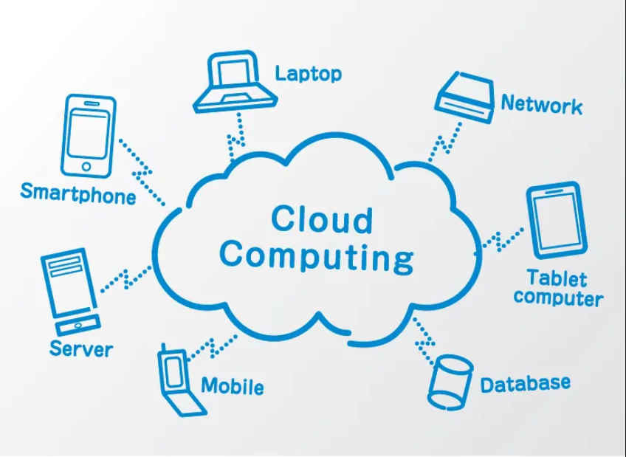

TASK 2 – TRACE THE EVOLUTION AND HARDWARE EVOLUTION (3 MARKS)
Further explanation: The move to cloud computing was not caused by one invention. It resulted from the combination of cheaper standardised servers, processors capable of running multiple workloads, reliable high-speed networks, large-scale storage and software that automates provisioning. Virtualisation made it possible to separate an application environment from the physical server. Automation then made it possible to create, monitor and remove those environments quickly. For the university, this evolution explains why replacing twelve dedicated servers with a shared, managed platform is technically practical.
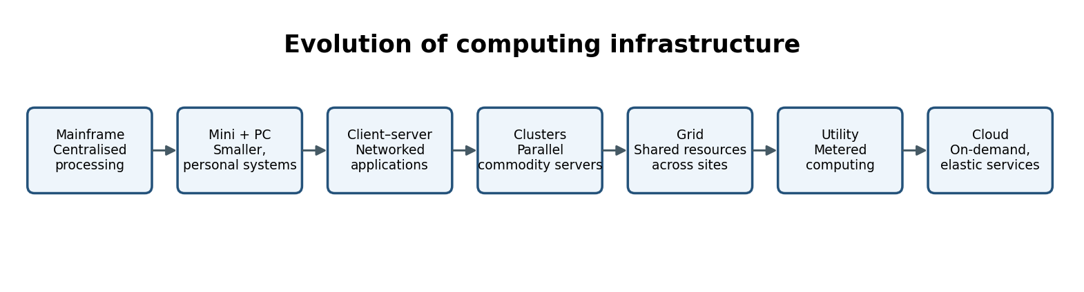

.
Stage | Limitation addressed / contribution | University relevance
Mainframes | Centralised high-capacity processing replaced many isolated manual systems, but was expensive and centrally controlled. | The current central data-centre approach resembles centralised computing.
Minicomputers and PCs | Reduced cost and brought computing closer to departments and individuals; created distributed islands of data. | Department-level systems can create duplication and inconsistent records.
Client–server | Separated user interface and central application/data services over networks. | Many legacy university applications follow this pattern.
Clusters | Connected commodity servers to work together for performance and availability. | Can provide scale-out capacity for busy services.
Grid computing | Coordinated distributed resources across administrative or geographic boundaries. | Conceptually supports sharing compute across campuses or institutions.
Utility computing | Introduced metered, service-like access to computing capacity. | Provides the economic idea of paying for measured consumption.
Cloud computing | Combines virtualisation, automation, networking, pooled resources and service delivery. | Enables on-demand, elastic services for students, staff and partner colleges.

2.1 Hardware advances that enabled cloud
- Multi-core processors: execute multiple workloads concurrently and improve server consolidation.
- Commodity servers: provide cost-effective building blocks that can be added in groups.
- High-capacity storage: supports large databases, documents, backups and replicated copies.
- High-speed networking: connects servers, storage and users with lower latency and higher throughput.
- Large data centres: provide redundant power, cooling, physical security and network connectivity at scale.

2.2 Which stage is the current university system?
The university mainly represents a traditional client–server / dedicated-server data-centre stage. Each application has a dedicated physical server and the applications are monolithic. The 15% average CPU utilisation and over-95% peaks show that resources are statically assigned rather than pooled elastically. It has not yet adopted the automation, elasticity and measured service characteristics of a mature cloud environment.
How hardware evolution supports the proposed migration
Modern cloud platforms build on data-centre hardware, virtualisation, high-speed networking, distributed storage and automated management. The university can use virtual machines for applications that need a complete operating system, containers for portable application deployment and managed services for common capabilities such as databases and queues. This combination reduces the need to purchase hardware for every new workload. It also makes capacity planning more continuous: administrators can monitor demand, adjust resource sizes and review whether the selected architecture remains cost-effective.

Why the university's current hardware is inefficient
The scenario reports twelve physical servers with average CPU utilisation of only 15%, but peak utilisation above 95%. This suggests that capacity has been purchased to handle occasional high demand and remains underused during ordinary periods. Low average CPU utilisation does not necessarily mean that every server is oversized: memory, storage latency, database locking and network traffic may be limiting factors. The university should profile each workload before consolidation and identify applications that require dedicated resources, special licences or unusual hardware settings.

Hardware evolution and its impact
Early computing systems were large, expensive and difficult to expand quickly. Improvements in processor performance, memory density, storage capacity and network speed made smaller servers and data centres practical. Blade servers and rack servers increased physical density, while multi-core processors enabled a single machine to execute many workloads. Virtualisation then allowed several isolated virtual machines to share one physical host. More recently, containers have provided a lighter way to package applications and their dependencies, making deployment and scaling more consistent.

Evolution from mainframes to distributed computing
University computing has evolved from centralised mainframe systems to client-server environments and then to distributed web-based systems. In a mainframe model, processing and data were concentrated in a central system and users accessed it through terminals. Client-server computing distributed some processing to desktop computers while central servers managed shared applications and databases. As internet use expanded, web applications made services available through browsers and connected systems across different locations. Cloud computing extends this progression by providing virtualised and managed resources through network services.
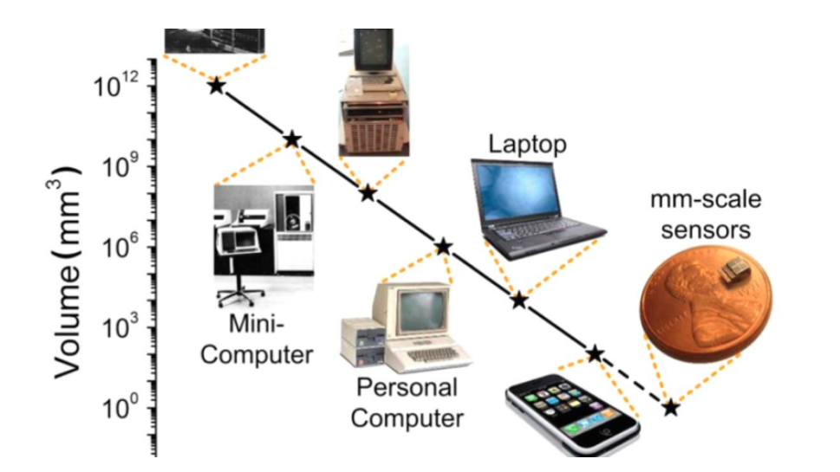

TASK 3 – ANALYSE INTERNET SOFTWARE EVOLUTION (3 MARKS)
Further explanation: The key design change is the separation of the user interface from the business functions and data. A mobile app should not contain its own copy of fee rules or student-record logic. Instead, it should send a secure request to a university API, and the API should validate the user, apply the relevant business rules and return only the permitted information. This approach reduces duplicated code and makes it easier to update the portal, mobile app and college integrations consistently. API versioning is important so that an update does not unexpectedly break older clients.
Stage | Main characteristics | Effect on university design
Static web pages | Pre-written HTML pages; limited interaction. | Suitable only for announcements or simple public information.
Dynamic web | Server-side programs generate pages using data and user input. | Supports student login, fee status and personalised dashboards.
Web 2.0 | Interactive, collaborative and responsive web applications; AJAX updates page content asynchronously. | Improves LMS interaction, library search and responsive student services.
SOA | Applications expose reusable business functions as services with defined contracts. | SIS, fees, library and examination functions can be reused by portals and mobile apps.
Mashups | Combines data or services from multiple sources through APIs. | A campus dashboard can combine timetable, library and notices.
Cloud-hosted applications | Applications run on scalable provider infrastructure and are accessed through browsers or APIs. | Allows elastic access across campuses and affiliated colleges.

3.1 Enabling technologies
- Browser: provides a common client interface without installing a separate desktop program on every device.
- HTTP/HTTPS: carries requests and responses; HTTPS adds transport encryption.
- AJAX: lets a page request data asynchronously and update part of the screen without a full reload.
- APIs: define controlled ways for mobile apps, portals and partner systems to access university functions.

3.2 Software delivery comparison
Aspect | Desktop software | Client–server software | Web-delivered software
Installation | Installed on each computer. | Client software may need installation/configuration. | Usually accessed through a browser or mobile app.
Updates | Often require device-by-device updates. | Client and server updates may both be needed. | Central server-side updates are easier.
Access | Usually tied to installed device. | Requires network and compatible client. | Accessible across supported devices with network access.
Scaling | Depends on individual devices and local deployment. | Server capacity must be managed. | Can use load balancing, auto-scaling and managed services.
University example | Legacy desktop administration tool. | Existing SIS client connected to a database server. | New student portal and mobile application.

Design impact: the university should gradually separate monolithic business logic into service interfaces, beginning with read-only student information and library search. It should use HTTPS, documented REST APIs, authentication and versioning so that a mobile application and partner colleges do not connect directly to internal databases.
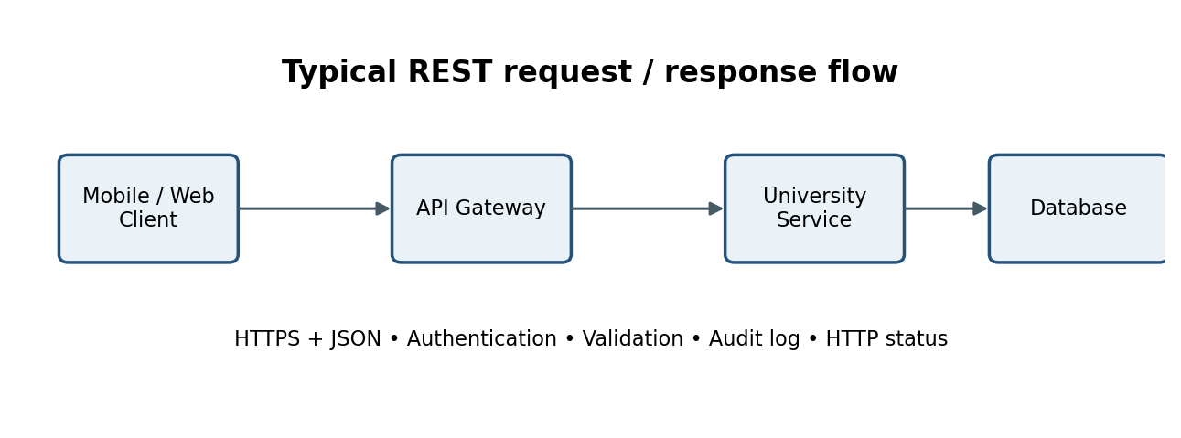
Figure 2. Typical API request and response flow.
A practical transition path
The university should not attempt to replace every application in one release. It can first introduce an integration layer that wraps selected legacy functions with controlled APIs. The mobile app and new portals can use these interfaces while the underlying application remains in place. Over time, high-change or high-demand functions can be separated into independently deployable services. This approach reduces the need for a risky full rewrite and allows the university to modernise incrementally while maintaining existing academic operations.
Role of web technologies in cloud migration
HTTP and HTTPS provide the common request-response foundation for browser and API communication. REST-style APIs commonly use resources, standard HTTP methods and JSON representations, making them suitable for mobile and web clients. SOAP-based services may still be encountered in older enterprise systems and can be retained temporarily where replacement would be risky. Identity standards such as OAuth 2.0 and OpenID Connect help applications obtain and validate access tokens without sharing user passwords with every service.
From tightly coupled systems to service-based integration
A monolithic application typically packages several business functions into one deployable unit. This can be straightforward when the system is small, but changes become harder as the application grows. A tightly coupled university environment may require the LMS to depend on the SIS database directly or may use custom scripts to transfer student records. A service-oriented or API-based design exposes specific functions through defined interfaces. Each consuming application can then request only the information it is authorised to use.
From static websites to dynamic applications
The early web mainly delivered static pages containing information that changed infrequently. As server-side programming, databases and browser technologies improved, websites became dynamic applications that could authenticate users, retrieve records and process transactions. Universities began using web portals for admissions, fee payments, course registration, attendance and examination results. These systems improved access but often developed as separate applications with their own databases and business rules.

TASK 4 – APPLY SERVER VIRTUALIZATION (5 MARKS)
Further explanation: Consolidation must be based on more than average CPU utilisation. Before moving workloads, administrators should collect CPU, memory, disk latency, storage capacity and network measurements during both normal and peak periods. They should group workloads according to performance and security needs, reserve capacity for the examination system and avoid placing every critical application on one host. The three-host calculation is the mathematical result under the stated average-CPU assumptions; the practical four-host recommendation provides additional operational headroom. A failover test should confirm that critical VMs can restart on surviving hosts without exhausting their resources.

4.1 Hypervisor operation and types
A hypervisor, also called a virtual machine monitor, allocates physical CPU, memory, storage and network resources to virtual machines. Each VM receives virtual hardware and runs its own guest operating system. The hypervisor schedules access to the physical host and maintains isolation between VMs.
Type | Operation | Examples / use
Type-1 (bare-metal) | Runs directly on physical server hardware; generally preferred for production consolidation. | VMware ESXi, Microsoft Hyper-V, KVM-based platforms; recommended for university hosts.
Type-2 (hosted) | Runs as an application on top of a host operating system. | Oracle VirtualBox, VMware Workstation; suitable for student labs and proof-of-concept testing.

4.2 Virtualization techniques
Technique | Explanation | Use / limitation
Full virtualization | Guest OS runs without modification on virtual hardware. | Strong compatibility for legacy SIS, LMS and examination systems.
Para-virtualization | Guest OS is aware of the hypervisor and uses special interfaces/drivers for efficient operations. | Can reduce overhead, but may require guest support or modification.
OS-level virtualization (containers) | Multiple isolated user spaces share the host OS kernel. | Efficient for stateless APIs and modern web services; not a replacement for a different guest kernel.
Hardware-assisted virtualization | CPU features such as Intel VT-x or AMD-V help execute guest operating systems efficiently. | Should be enabled on physical hosts to improve VM performance and isolation.

4.3 Proposed VM and container placement
Workload | Recommended platform | Reason
Legacy SIS | VM | Preserves its existing OS/runtime and allows controlled migration.
Legacy LMS | VM initially; containerise after refactoring | Reduces migration risk while enabling later scale-out.
Library system | VM or managed application platform | Legacy database compatibility may require a VM; web/API tier can be containerised.
Examination portal | VM for legacy core; containerised front end/API | Separates stable legacy logic from elastic user-facing components.
Email | SaaS email service | Email is a commodity service; provider handles patching, spam filtering and availability.
New API and integration services | Containers on managed orchestration / PaaS | Fast deployment, independent scaling and consistent runtime.

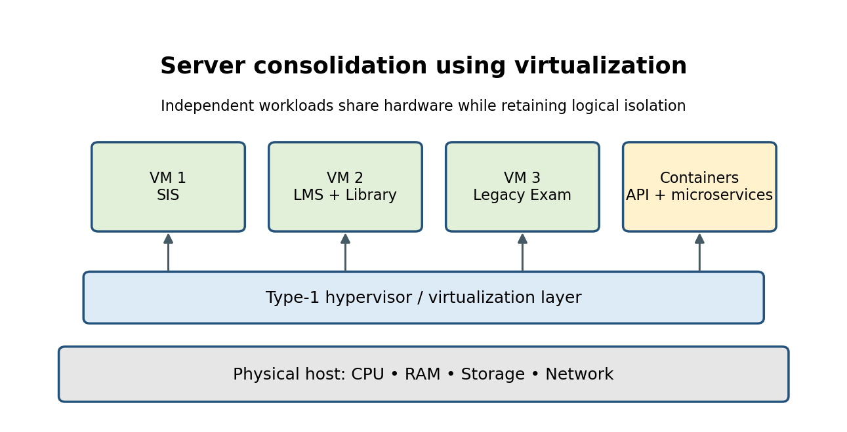
Figure 3. Logical consolidation of university workloads onto virtualised hosts.

4.4 Consolidation calculation
Assumptions: all 12 physical servers have equal CPU capacity; average utilisation is 15% per server; workloads can be safely consolidated; target average host utilisation is 70%; and the calculation is based on average CPU demand only. Memory, storage IOPS, network throughput, redundancy and peak demand must be checked separately.
Step 1 – Total average CPU load, expressed in server-equivalents:
12 servers × 15% = 180% = 1.8 fully utilised server-equivalents.
Step 2 – Number of hosts at the target 70% utilisation:
Required hosts = 1.8 ÷ 0.70 = 2.571. Round up = 3 physical hosts.
Step 3 – Capacity check:
3 hosts × 70% = 2.1 server-equivalents of planned capacity, which is greater than the 1.8 average load. Therefore, three hosts are the mathematical minimum under the stated average-load assumptions.
Practical recommendation: deploy at least 4 hosts in a production cluster (three hosts for normal planned load plus one host's worth of failover/maintenance headroom, subject to workload sizing). The 3-host result is not a peak-load guarantee. A measured peak above 95% on each original server could produce a much larger combined demand; benchmark CPU, RAM, storage and network during admission/exam simulations before final procurement.

4.5 Benefits and risks
Feature / risk | Explanation and control
Live migration | Moves a running VM between compatible hosts with little downtime; use for maintenance and load balancing.
Snapshots | Capture a point-in-time VM state for short-term rollback; do not treat snapshots as independent backups.
Resource over-commitment | Allocates more virtual CPU or memory than physically available; use conservative ratios, monitoring and reservations for exams.
Noisy neighbour | One workload consumes shared CPU, memory or I/O; use resource limits, reservations and workload placement.
Hypervisor failure | Can affect multiple VMs; use clustered hosts, redundant power/network and tested recovery.
Security isolation | A hypervisor flaw or misconfiguration can expose workloads; patch hosts, harden management access and segment networks.

Validation before final host selection
The IT team should collect at least several weeks of performance data, including normal days and known peak periods. It should identify the busiest time windows and test representative combinations of SIS, LMS, library and examination workloads. The team should verify CPU-ready time, memory utilisation, disk IOPS, storage latency and network throughput after consolidation. A pilot migration should be completed before the remaining servers are moved. Acceptance should require that response times remain within agreed limits and that a host failure does not cause unacceptable service interruption.

Consolidation calculation and practical interpretation
Using the supplied average figures, twelve servers multiplied by 15% average CPU utilisation equals 1.8 fully utilised server-equivalents. If the target average utilisation is 70%, the simple estimate is 1.8 divided by 0.70, or approximately 2.57 hosts; rounding upward gives a mathematical minimum of three equivalent hosts. A fourth host is a safer planning option where maintenance, failure tolerance and workload growth must be considered. This calculation is only an average-CPU estimate and must not be used as the final purchase specification.

Benefits and limitations for the scenario
Virtualisation can improve hardware utilisation, simplify provisioning, isolate workloads and support snapshots or migration between compatible hosts. It can also make it easier to create separate development, testing and production environments. However, virtualisation does not remove the need for capacity planning. If too many virtual machines are placed on one host, CPU scheduling, memory pressure and storage contention can reduce performance. A host failure can affect several virtual machines unless the platform has sufficient redundancy and recovery capability.

Virtualisation concept and hypervisor operation
Server virtualisation uses a software layer called a hypervisor to divide the resources of a physical server into multiple virtual machines. Each virtual machine receives virtual CPU, memory, storage and network interfaces and can run its own guest operating system. A Type-1 hypervisor runs directly on the host hardware and is commonly used in data centres. A Type-2 hypervisor runs on top of a host operating system and is useful for desktop learning, testing and demonstrations. The university's production consolidation design would normally use an enterprise Type-1 platform or a cloud provider's virtualisation layer.

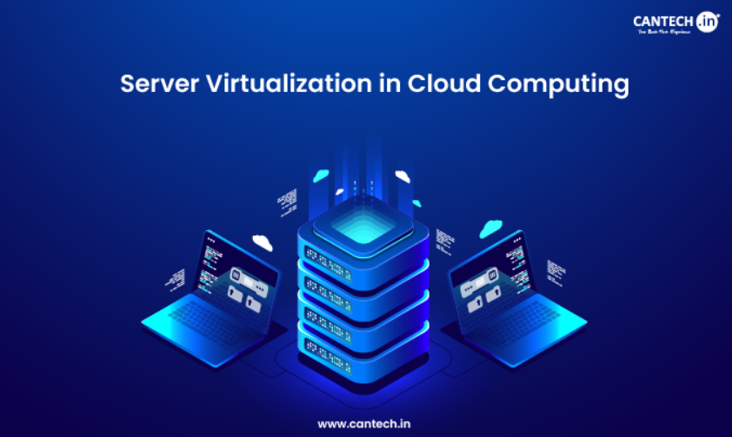

TASK 5 – APPLY WEB SERVICES (4 MARKS)
Further explanation: An API is a controlled contract between the provider of a function and the software that uses it. The contract should state the endpoint, method, input fields, response structure, error codes and authentication requirements. For example, a college should receive only the student information it is authorised to view, not unrestricted access to the SIS database. Payment processing should also be designed for retries: if a network timeout occurs, the client must not accidentally create multiple payments. An idempotency key and transaction reconciliation process help prevent duplicate payment operations.

5.1 Web services and SOA
A web service exposes a defined software function over a network using standard protocols and data formats. In Service-Oriented Architecture (SOA), business capabilities are exposed as reusable, loosely coupled services. A mobile app, student portal and affiliated-college system can call the same approved service instead of duplicating business logic or accessing the database directly.

5.2 SOAP, WSDL, UDDI and REST
Technology | Purpose | University use
SOAP | XML-based messaging protocol with a formal envelope and extensions for enterprise messaging/security. | Useful where a payment or institutional integration requires a strict contract and WS-* standards.
WSDL | XML document describing SOAP service operations, messages and endpoint details. | Documents a formal SOAP contract for an external integration.
UDDI | Registry concept for publishing and discovering web-service descriptions. | Historically used for service discovery; a modern university may use an internal API catalogue instead.
REST | Architectural style using resources and standard HTTP methods; commonly JSON over HTTPS. | Recommended for mobile, portal and college integrations due to simplicity and broad support.

5.3 Proposed university APIs
Function | Endpoint and method | Sample request | Sample response | Choice
Result lookup | GET /api/v1/students/{studentId}/results?semester=5 | Path studentId=STU1024; semester=5 | {"studentId":"STU1024","semester":5,"status":"published","subjects":[{"code":"CS501","grade":"A"}]} | REST: read-heavy, mobile-friendly JSON response.
Library search | GET /api/v1/library/books?q=cloud&available=true | Query: q=cloud, available=true | {"count":2,"items":[{"isbn":"978013","title":"Cloud Computing"},{"isbn":"978149","title":"Cloud Native"}]} | REST: simple search/filter and cacheable read requests.
Student profile for college | GET /api/v1/colleges/{collegeId}/students/{studentId} | Authorised college token; collegeId=C014; studentId=STU1024 | {"studentId":"STU1024","name":"Sample Student","programme":"BSc IT","consent":"verified"} | REST behind API gateway; strict tenant and field-level authorisation.

All endpoints must use HTTPS, OAuth 2.0 / OpenID Connect tokens, input validation, rate limits, audit logging and versioned paths. Payment data should be tokenised and handled by a compliant payment gateway; the university should not store raw card details.
Example HTTP response codes: 200 OK for a successful read, 201 Created for a payment request, 400 Bad Request for invalid input, 401 Unauthorized for missing/invalid login, 403 Forbidden for insufficient permissions, 404 Not Found for an unknown record and 429 Too Many Requests for rate limiting.
API lifecycle management
Each API should have an identified owner, documented purpose, schema, authentication requirement, version and support contact. Automated tests should check both successful and unsuccessful requests. A deprecation policy should give mobile developers and affiliated colleges enough time to move from an older API version to a supported version. The university should monitor usage by client and tenant, identify outdated integrations and revoke credentials that are no longer required. These controls are essential when the number of API consumers grows beyond the four campuses.
API gateway and service responsibilities
The API gateway provides a common entry point for client applications. It can validate tokens, apply rate limits, route requests, enforce request-size limits and collect access logs. The backend service must still verify the user's permission to access the specific student or college record. The gateway should not be treated as a replacement for application-level authorisation. For reliability, services should use timeouts, bounded retries and circuit breakers so that a slow downstream service does not exhaust all application resources.
Example API resource design
A resource-oriented API could expose GET /api/v1/students/{studentId} for an authorised profile lookup, GET /api/v1/students/{studentId}/enrolments for course enrolments, GET /api/v1/courses/{courseId} for course details and POST /api/v1/fee-payments for creating a payment request. A POST request should use an idempotency key or equivalent mechanism where duplicate submissions could create duplicate payment operations. Sensitive actions such as changing a student's programme or publishing marks should use stricter permissions and additional audit controls.
How the proposed APIs support real university workflows
The Student Information System should remain the authoritative source for student identity, programme, enrolment and academic status. The LMS can request a permitted subset of this information to create course access. The Library service can verify whether a student is active before allowing selected borrowing functions. The examination portal can retrieve course registration and eligibility information before accepting an examination application. The mobile app can call the same APIs to show a student's timetable, attendance summary or examination notifications. This avoids maintaining separate copies of business rules in every client.


TASK 6 – ANALYSE IaaS, PaaS AND SaaS (5 MARKS)
Further explanation: The service model should be selected separately for each application rather than forcing every system into the same category. A legacy application may need operating-system access and therefore begin on IaaS. A newly developed API can use PaaS because the university wants to focus on code rather than patching servers. Email is a mature standard service and is usually better consumed as SaaS. The university must nevertheless retain responsibility for data classification, account lifecycle, access permissions, configuration and checking that the provider meets contractual and legal requirements.

6.1 Definitions and responsibility layers

IaaS supplies virtualised compute, storage and networking. PaaS supplies a managed application runtime and development platform. SaaS supplies a complete application to end users. As we move from IaaS to SaaS, the provider manages more of the technology stack and the university gives up some low-level control.

Layer | On-premise | IaaS | PaaS | SaaS
Physical data centre / networking | University | Provider | Provider | Provider
Virtualisation / servers / OS | University | Provider manages physical layer; customer manages guest OS | Provider | Provider
Runtime / middleware | University | University | Provider | Provider
Application | University | University | University deploys code; platform manages runtime | Provider
Data and user configuration | University | University | Shared / university governs its data | University governs data and configuration

6.2 Application mapping
Application | Recommended model | Reason
SIS | IaaS initially, then selective PaaS modernisation | A legacy monolith may need OS/database control during migration; new modules can move to managed runtimes.
LMS | SaaS if functional and data requirements fit; otherwise PaaS/IaaS | A mature education LMS can reduce patching and operations; custom integrations must be validated.
Library System | PaaS for modern web/API components; IaaS for legacy database if required | Separates the searchable web interface from legacy data components.
Examination Portal | PaaS / containers for the web and scheduling tier; protected VM for legacy engine | Elastic front-end capacity is valuable during exam windows; maintain strict exam integrity controls.
Email | SaaS | Email is standardised and benefits from provider-managed spam protection, patching and availability.

6.3 Model comparison

Factor | IaaS | PaaS | SaaS
Control | Highest control over guest OS and software; provider manages hardware. | Control over application code and data; provider manages runtime/platform. | Lowest infrastructure control; customer configures users, policies and data.
Cost | Compute/storage/network charges plus OS, patching and operations. | Managed runtime reduces administration; charges depend on app usage and platform tier. | Subscription per user or usage; predictable for stable user counts but can grow.
Scalability | Possible but requires configuration and operations. | Often built-in scaling and managed services. | Provider scales the application; customer controls plan and usage.
Maintenance effort | High: OS, middleware and application patching. | Medium: application and data remain customer responsibility. | Low infrastructure effort; vendor manages application platform.
Vendor lock-in | Moderate; VM images and standard OSs can aid portability. | Can be higher due to platform APIs and managed service features. | Potentially high due to data formats, workflows and proprietary features.

6.4 Provider examples
- IaaS: Amazon EC2, Microsoft Azure Virtual Machines or Google Compute Engine.
- PaaS: Azure App Service, Google App Engine or AWS Elastic Beanstalk.
- SaaS: Microsoft 365 / Exchange Online or Google Workspace for Education; a hosted LMS may be selected after procurement and compliance review.
These are examples, not an endorsement. The university should evaluate regional hosting, contractual data processing, identity integration, service-level commitments, exit/export options and total cost before selecting a provider.

Decision matrix and recommendation
The service model should be selected according to the workload rather than by choosing one model for the whole university. A legacy system may begin on IaaS to reduce migration risk, a new API can use PaaS to simplify deployment, and email can use SaaS to avoid operating a commodity service internally. Before approval, the university should compare control, skills, security responsibilities, availability, portability, pricing and exit arrangements. A small proof of concept should verify that the selected service works with the university's identity provider and existing data formats.

Detailed SaaS application
Software as a Service provides a complete application through a subscription or usage-based model. Users access the software through a browser or client, while the provider operates the application and underlying platform. University email and collaboration are examples of services that may be consumed as SaaS. A hosted LMS may also be considered if it meets teaching, accessibility, integration, privacy and procurement requirements. The university must still configure users and roles, protect information, manage retention and review the provider's contractual obligations.

Detailed PaaS application
Platform as a Service provides a managed environment for building, deploying and running applications. The provider manages much of the underlying operating system and platform maintenance, while the university manages application code, configuration, data and access policies. PaaS is suitable for new REST APIs, web front ends, background workers and managed databases when the application is compatible with the platform. It can improve developer productivity and release consistency, but the team must understand supported runtimes, quotas, scaling behaviour and service limits.

Detailed IaaS application
Infrastructure as a Service provides virtual machines, virtual networks, storage volumes and related infrastructure components. It is suitable for legacy SIS or examination modules that require a particular operating system, installed runtime or direct administrative control. The university remains responsible for guest operating-system patching, application updates, configuration, identity, data protection and many network controls. IaaS offers a relatively direct migration path, but it can preserve old architecture and may require more operational effort than managed platforms.
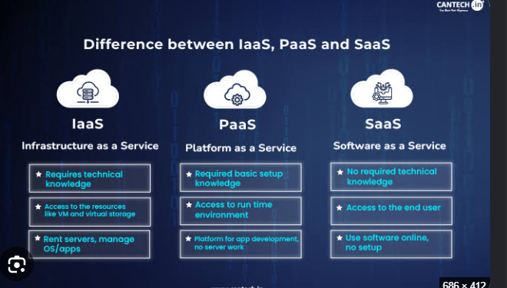

TASK 7 – EXAMINE XAAS (3 MARKS)
Further explanation: XaaS offerings can reduce the amount of specialist infrastructure the university must operate, but each service creates a dependency. A managed database can simplify patching and backup operations, yet the university must understand how to export its data and restore it elsewhere. A DR service is useful only when the recovery plan is documented, people know their roles and recovery exercises are performed. The university should maintain a register of service owners, service-level commitments, data locations, renewal dates and exit procedures for every important provider.
XaaS (Anything-as-a-Service) is the delivery of technology capabilities as services over a network, usually with subscription or usage-based pricing. It allows the university to consume specialised capabilities without owning and maintaining every component.
Variant | Meaning | Possible university application
DaaS – Database as a Service | Provider operates database infrastructure, patching, backups and failover. | Managed SIS reporting or library catalogue database after compatibility and privacy review.
BaaS / MBaaS – Backend / Mobile Backend as a Service | Provides common mobile backend capabilities such as authentication, push notifications and data synchronisation. | Mobile student app login, notification and device registration.
FaaS – Function as a Service | Runs event-triggered functions without managing long-lived servers. | Send result-publication notifications or process payment callbacks.
Security as a Service | Managed security capabilities such as WAF, threat detection and identity protection. | Protect public APIs and detect suspicious college access.
DRaaS – Disaster Recovery as a Service | Provides recovery infrastructure, replication and orchestration. | Restore critical student and exam services after a regional outage.

7.1 Two recommended XaaS offerings
1. DBaaS: A managed relational database for modernised SIS/API workloads reduces database patching and provides automated backups, monitoring and multi-zone failover. It is recommended only after confirming database compatibility, encryption, residency and export capability.
2. DRaaS: A separately located recovery environment with replicated backups and documented recovery procedures addresses the current absence of a disaster-recovery site. The university must test restoration rather than relying only on a provider's feature description.

7.2 Risks of multiple providers
- Integration complexity: identity, monitoring, billing and data formats may differ.
- Vendor lock-in and exit costs: proprietary APIs and data-transfer charges can make switching difficult.
- Shared-responsibility gaps: each provider may assume another party secures a component.
- Outage concentration: several services may depend on one identity, DNS or network provider.
Controls include a service inventory, standard APIs, data-export tests, central identity, consolidated logging, clear contracts and an accountable service owner for each provider.
Exit and continuity planning
Before adopting a critical XaaS product, the university should test how to export its data in a usable format and how long a replacement service would take to configure. It should document alternative access methods if a provider becomes unavailable and avoid depending on a single provider for every critical control where practical. Disaster recovery must include people, procedures, credentials, network access and application configuration, not only replicated data. Recovery exercises should record actual recovery times and unresolved issues.
Risks and governance across providers
Using several providers can create fragmented identity, separate monitoring consoles, inconsistent backup policies and uncertainty about who responds to an incident. The university should maintain a service register that records the provider, data stored, service owner, support contact, region, recovery process, renewal date and exit method. Contracts should clarify data ownership, incident notification, service-level commitments, subcontractors, retention and deletion. A periodic review should confirm that each service still meets its original purpose.
Benefits of consuming services
A service-based model can convert large upfront purchases into more predictable operating expenses and allow the university to access specialist capabilities sooner. Managed services may include routine patching, monitoring, redundancy and support that would otherwise require internal staff. Usage-based charging can be cost-effective when demand varies. However, the university must monitor consumption because uncontrolled storage growth, data transfer, excessive logging or over-provisioned service tiers can increase monthly bills.
Additional XaaS categories relevant to the university
Besides Database as a Service and Disaster Recovery as a Service, the university may use Storage as a Service for documents and backups, Identity as a Service for central authentication, Security as a Service for threat detection and managed protection, and Backup as a Service for protected copies of important records. These services can reduce the need to operate specialist infrastructure internally. Their suitability depends on data sensitivity, integration requirements, service availability, contract terms and the university's ability to export information.

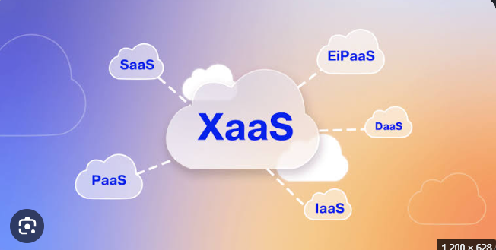

TASK 8 – DESIGN THE CLOUD SOLUTION ARCHITECTURE (5 MARKS)
Further explanation: The architecture uses multiple layers so that each component has a clear responsibility. The load balancer distributes traffic, the API gateway applies common access policies, the application tier performs business logic and the database tier stores authoritative records. Static files can be delivered through a content delivery network, while queues move slow tasks such as notifications out of the immediate user request. This prevents a temporary delay in an email or notification service from blocking a student's result lookup. Private database networking and least-privilege access reduce the attack surface.
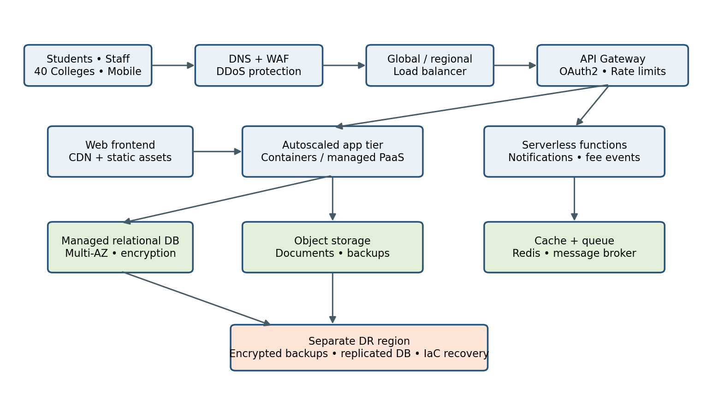
Figure 4. Proposed hybrid cloud architecture for the university.

8.1 Component and service-model justification
Component | Model / deployment | Purpose and design decision
DNS, CDN and WAF | SaaS / public cloud | Distribute static content, filter malicious traffic and protect the public entry point.
Load balancer | Managed PaaS / public cloud | Distribute HTTPS requests across healthy application instances and availability zones.
API gateway | Managed PaaS / public cloud | Central authentication enforcement, routing, throttling, versioning and audit controls.
Web and application tier | Containers on managed PaaS; selected legacy VMs on IaaS | Scale modern services horizontally while retaining compatibility for legacy applications.
Database tier | DBaaS / public cloud with private networking | Managed relational data, encryption, backups and multi-zone high availability.
Object storage | Managed cloud storage | Store documents, exports, logs and backup copies with lifecycle policies.
Cache and message queue | Managed PaaS | Reduce database pressure and process notifications/payment events asynchronously.
DR region | DRaaS / IaaS plus replicated managed services | Recover critical services if the primary region is unavailable.

8.2 Elasticity strategy
- Use metrics such as CPU, request rate, queue depth and response time to trigger autoscaling.
- Scale stateless web/API containers horizontally; keep session state in a shared cache or database.
- Use scheduled pre-scaling before known admission, fee-payment and exam windows.
- Cache read-heavy public information and use queues for notifications so a sudden burst does not overload the database.
- Set maximum instance counts, budgets and alerts to prevent runaway spending.

8.3 Security and availability
- Identity: single sign-on, multi-factor authentication for staff/admins, least-privilege roles and short-lived service credentials.
- Network: private subnets for databases, security groups, network segmentation and restricted management access.
- Data: TLS in transit, encryption at rest, managed keys, backup encryption and retention controls.
- Application: input validation, secure coding, WAF, API throttling, vulnerability scanning and audit logs.
- Availability: deploy across at least two availability zones, health checks, automated backups and tested DR runbooks.
Proposed recovery objectives for planning: critical student-record services RPO ≤ 15 minutes and RTO ≤ 4 hours; less critical content services may have longer targets. These are proposed targets that require cost and business-impact approval, not guaranteed provider values.
Architecture trade-offs and implementation sequence
A fully microservice-based redesign may provide independent scaling, but it also increases deployment, monitoring and debugging complexity. The university should begin with a modular architecture and separate only services that have a clear reason to scale or change independently. A practical order is to establish identity, networking, logging and backup first; then deploy the API gateway and a pilot application; then migrate application services and databases in controlled waves. This sequence creates a secure foundation before large-scale user migration.
Resilience, monitoring and operations
The production architecture should distribute application instances across at least two availability zones where supported. Health checks should remove unhealthy instances from load balancing, while automated deployment should replace failed instances. Critical databases need backup, replication and tested failover procedures. Central monitoring should collect application latency, error rates, CPU, memory, database connections, queue depth and security events. Alerts should be linked to runbooks that identify the responsible team and the steps needed to diagnose the issue.
Data, integration and asynchronous processing
The SIS should be treated as the authoritative source for student identity and enrolment, while other applications receive only the data needed for their function. An integration service or event bus can publish events such as course registration completed, fee payment confirmed or examination timetable released. Other services can subscribe to these events and update their own records without repeatedly querying the SIS. Queues are useful for tasks such as sending email or mobile notifications because these tasks can be processed after the main user request has completed.
End-to-end architecture flow
A student or staff member accesses the university portal or mobile application through HTTPS. DNS directs the request to a protected public entry point, where a web application firewall filters common threats and a load balancer distributes requests across healthy application instances. The API gateway validates the client token, checks general request policies and forwards the request to the relevant service. The application service applies business rules and retrieves permitted data from a private database or object store. The response returns through the gateway to the user.

TASK 9 – HANDS-ON IMPLEMENTATION AND DOCUMENTATION (4 MARKS)
Further explanation: A proof-of-concept is intended to demonstrate the deployment pattern, not to reproduce the full production university system. The sample API uses synthetic student records and provides one successful lookup and one not-found response. In the final submission, record the operating system, Docker version, commands entered, date of testing and actual output. Screenshots should show enough of the terminal or browser to identify the test and its result. Never include real student details, passwords, API keys or payment information in screenshots or source files.
Purpose: demonstrate one university function as a small REST API in a local Docker container. The following is a reproducible proof-of-concept procedure. The report cannot truthfully claim that commands were executed on the student's device; insert genuine screenshots and actual terminal output after running the steps.

9.1 Example Flask API
Create a folder named university-api and save the following as app.py:
from flask import Flask, jsonify
app = Flask(__name__)
students = {
"STU1024": {"name": "Sample Student", "programme": "BSc IT", "status": "Active"},
"STU1025": {"name": "Demo Student", "programme": "BCA", "status": "Active"}
}
@app.get("/health")
def health():
return jsonify({"status": "ok", "service": "university-api"})
@app.get("/api/v1/students/<student_id>")
def get_student(student_id):
student = students.get(student_id)
if student is None:
return jsonify({"error": "Student not found"}), 404
return jsonify({"studentId": student_id, **student}), 200
if __name__ == "__main__":
app.run(host="0.0.0.0", port=5000)
Save requirements.txt:
Flask==3.1.0
Save Dockerfile:
FROM python:3.12-slim
WORKDIR /app
COPY requirements.txt .
RUN pip install --no-cache-dir -r requirements.txt
COPY app.py .
EXPOSE 5000
CMD ["python", "app.py"]

9.2 Build and run
docker build -t university-api .
docker run --name university-api-demo -p 5000:5000 university-api
docker ps
Open http://localhost:5000/health in a browser or run: curl http://localhost:5000/health
Expected response (illustrative):
{"service":"university-api","status":"ok"}
Test a valid student: curl http://localhost:5000/api/v1/students/STU1024
Expected response (illustrative):
{"studentId":"STU1024","name":"Sample Student","programme":"BSc IT","status":"Active"}
Test an unknown student: curl -i http://localhost:5000/api/v1/students/UNKNOWN
Expected result: HTTP/1.1 404 NOT FOUND and {"error":"Student not found"}. These are expected outputs from the code, not captured execution evidence.

9.3 SaaS/PaaS component and documentation
For the second component, deploy the same container to a managed application platform (for example Azure App Service for Containers, Google Cloud Run or AWS App Runner) using a student/free-tier account only after checking current pricing and eligibility. Alternatively, use a managed database as a PaaS component. Configure environment variables and restrict public access if real student data is involved. Use synthetic data only for this assignment.
Test | Action | Expected result / evidence to capture
Container build | Run docker build command. | Successful image build in terminal; screenshot 1.
Container running | Run docker ps after docker run. | Container listed as running with port 5000 mapped; screenshot 2.
Health endpoint | Open /health in browser or curl. | HTTP 200 and JSON status ok; screenshot 3.
Valid student | Request /api/v1/students/STU1024. | HTTP 200 and sample JSON; screenshot 4.
Invalid student | Request /api/v1/students/UNKNOWN. | HTTP 404 and error JSON; screenshot 5.
Cloud deployment | Deploy to selected PaaS and open public test URL. | Deployment status and successful HTTPS response; screenshot 6.

9.4 Issues and limitations
- Docker Desktop may require WSL 2 on Windows; enable virtualisation in BIOS/UEFI if required.
- Port 5000 may already be in use; map another host port, for example -p 5001:5000.
- A free-tier platform may sleep, restrict resources or change its allowance; verify current terms.
- The sample data is in memory and disappears when the container restarts; production requires a persistent database, authentication and audit logging.
Screenshot placeholders: insert authentic screenshots from your own execution in the spaces below. Do not submit generated or illustrative images as proof of execution.
[Screenshot 1 – Docker image build – paste your actual screenshot here]
[Screenshot 2 – Running container – paste your actual screenshot here]
[Screenshot 3 – Health endpoint HTTP 200 – paste your actual screenshot here]
[Screenshot 4 – Student lookup HTTP 200 – paste your actual screenshot here]
[Screenshot 5 – Unknown student HTTP 404 – paste your actual screenshot here]
[Screenshot 6 – PaaS deployment – paste your actual screenshot here]
PaaS extension and comparison
To demonstrate a PaaS component, the same container can be deployed to a suitable managed container platform after checking the current student-account eligibility, regional availability and pricing. The student should configure the required port and environment variables, deploy the image and test the public or restricted endpoint. The report can compare the local Docker run with the managed deployment in terms of infrastructure responsibility, scaling options, deployment steps and cost. Real student data must not be uploaded to a demonstration environment.
Evidence and report preparation
The practical report should contain the actual commands used, the operating system and Docker version, the build result, container status and endpoint test results. Screenshots should be captured from the student's own system and labelled in the same order as the procedure. If the student encounters an error, the report should include the error message, the cause identified and the corrective action. Expected outputs shown in the assignment should be clearly distinguished from actual screenshots so that the documentation remains honest and reproducible.
Improvements required before production
A production student service must use a persistent database because the sample dictionary loses its contents when the process restarts. It must authenticate users, authorise access to each student record, validate identifiers, prevent injection attacks, protect secrets and encrypt communications. It should also include structured logs, request tracing, health and readiness probes, automated tests, vulnerability scanning and rate limiting. Sensitive fields should be minimised in API responses, and every access to protected student data should be recorded according to the university's audit policy.
What the demonstration proves
The health endpoint confirms that the sample process is responding. The valid student endpoint confirms that the route can locate a record in the sample in-memory data and return a JSON response. The unknown-ID test confirms that the application returns a 404 response instead of pretending that a record exists. Docker packaging demonstrates that the same application can be started in a repeatable container environment. These results are limited to the sample code and do not prove that the service can handle real university traffic.
Step-by-step explanation of the container workflow
First, create the project folder and save the Flask application, dependency file and Dockerfile. Second, build the image so that Docker installs the specified Python runtime and Flask dependency and copies the application into the image. Third, start a container and map a host port to the application's listening port. Fourth, check that the container is running and open the health endpoint. Finally, call the student lookup endpoint with both a valid sample ID and an unknown ID. The two tests demonstrate a successful response and a controlled not-found response.

TASK 10 – EVALUATE AND RECOMMEND THE FINAL SOLUTION (7 MARKS)
Further explanation: A fair cost comparison must include the full cost of operating each option, not only the price of a server or virtual machine. On-premise costs include hardware refresh, power, cooling, backup equipment, support and staff time. Cloud costs include compute, storage, network transfer, managed-service charges, monitoring, support and migration. The estimates in this report are planning assumptions to show the method of comparison; they are not quotations. The university should replace them with measured workload data and current provider calculator results before approving a budget.

10.1 Three-way comparison
Factor | On-premise | IaaS-based cloud | PaaS/SaaS-based cloud
Cost structure | High CapEx for servers, storage, power and DR; staff maintenance. | Lower initial CapEx but ongoing VM, storage, network and operations charges. | Mostly OpEx/subscription or usage charges; provider manages more operations.
Scalability | Slow; procurement takes 6–8 weeks. | Can provision VMs quickly, but OS and scaling operations remain with university. | Managed scaling is easier for stateless applications and standard services.
Availability | Single data centre and no DR site create a major failure risk. | Can use zones and backup regions, but university configures and tests them. | Provider-managed redundancy can improve availability; contract and architecture still matter.
Security | Direct physical control, but patching and resilience are university responsibility. | Shared responsibility; customer secures guest OS, identity and applications. | Provider secures platform; university remains responsible for identity, data, permissions and configuration.
Effort | High hardware, patching and capacity-planning effort. | Medium to high systems administration effort. | Lower infrastructure effort, but integration, governance and vendor management remain.

10.2 Three-year indicative cost comparison
Planning assumptions (illustrative, INR): 12 existing servers are replaced or refreshed as required; costs are rounded and exclude taxes, one-time application redevelopment, major bandwidth upgrades and inflation. Cloud estimates assume a moderate baseline with temporary peak scaling, not continuous 95% utilisation. Actual procurement quotations are required before approval.
Cost category | On-premise (3 years) | IaaS (3 years) | PaaS/SaaS mix (3 years)
Hardware / refresh / setup | ₹36,00,000 | ₹3,00,000 migration & setup | ₹2,00,000 setup & integration
Compute / platform / subscriptions | ₹0 incremental cloud | ₹36,00,000 (₹1,00,000/month) | ₹45,00,000 (₹1,25,000/month)
Storage, backup and DR | ₹9,00,000 | ₹9,00,000 | ₹6,00,000
Network and security tools | ₹6,00,000 | ₹6,00,000 | ₹6,00,000
Operations / support | ₹18,00,000 | ₹12,00,000 | ₹9,00,000
Estimated 3-year total | ₹69,00,000 | ₹66,00,000 | ₹68,00,000

Interpretation: the illustrative totals are close, so the decision should not be based on the lowest estimate alone. The PaaS/SaaS mix costs more in direct service charges but reduces infrastructure administration and improves elasticity. IaaS may be marginally cheaper in this assumption set but requires more internal skills. On-premise has the largest refresh and resilience burden. Recalculate using provider pricing calculators, actual concurrent users, storage growth, egress and support requirements.

10.3 Main risks and mitigations
Risk | Mitigation
Vendor lock-in | Use REST/HTTPS standards, container images, documented data schemas, regular export tests and exit clauses.
Data privacy / unauthorised access | Data classification, least privilege, MFA, encryption, audit logs, retention rules and privacy review.
Cloud or network downtime | Multi-zone design, health checks, backup connectivity for campuses, DR region and tested recovery runbooks.
Skills gap | Train administrators, use infrastructure as code, document operations and use a managed service where it reduces risk.
Unexpected cost growth | Budgets, tagging, quotas, alerts, autoscaling limits, storage lifecycle rules and monthly cost reviews.

10.4 Final recommendation and phased roadmap
Recommend a hybrid migration that progressively becomes a managed public-cloud platform for internet-facing and elastic services. Retain legacy SIS/examination components on protected IaaS VMs only until they are tested and modernised. Adopt SaaS for email and, where procurement confirms fit, LMS. Use PaaS for APIs, web front ends, queues and managed databases.
Phase | Activities | Reason / exit condition
0 – Assess and prepare | Inventory applications, dependencies, data classification, licensing, network and peak-load baselines; establish cloud landing zone. | No migration before owners, security controls, backup and rollback plans are agreed.
1 – Low-risk services | Move email to SaaS; pilot static website, API gateway and library search API. | Build cloud operations skills and validate identity/network integration.
2 – Data and application foundations | Set up managed database for a non-critical service; migrate library web tier and LMS after testing. | Validate performance, data consistency, access controls and vendor exit.
3 – Core student services | Migrate SIS modules in stages; keep legacy core on IaaS until reconciled; introduce API façade. | Protect records and avoid a risky big-bang cutover.
4 – Examination and optimisation | Migrate exam portal components after load/security tests; optimise autoscaling, DR and cost. | Exam integrity and availability require strict acceptance tests.

Final recommendation with measurable outcomes
The recommended option is a phased hybrid-cloud strategy that gradually increases the use of managed services. Legacy SIS and examination components can initially be hosted on protected IaaS while their dependencies are assessed. New APIs, web front ends and integration services should use PaaS where compatible, and standard collaboration functions can use SaaS after compliance review. Success should be measured through availability, response time, recovery performance, security findings, deployment lead time, infrastructure utilisation and actual monthly cost. Procurement should use current provider quotations rather than the illustrative estimates in this assignment.

Risk evaluation and mitigation
The major risks include migration downtime, data loss, unauthorised access, service-provider outages, unexpected cloud bills, skills gaps and vendor lock-in. These risks can be reduced through a pilot migration, data reconciliation, encryption, least-privilege access, multi-factor authentication, immutable backups, budget alerts, staff training and tested exit procedures. The university should maintain a risk register with a named owner, likelihood, impact, mitigation and review date. High-impact risks affecting examination or student-record services should receive priority.

Financial evaluation and total cost of ownership
The cost comparison should cover at least three years and use the same workload assumptions for each option. On-premises costs include server refresh, storage, network equipment, electricity, cooling, rack space, backup systems, disaster recovery, licences, maintenance and staff effort. Cloud costs include virtual machines or containers, managed databases, storage, backup, network transfer, load balancing, monitoring, security services, support and any licence charges. Migration costs, training and temporary parallel operation should be shown separately because they may be concentrated in the first year.

Technical evaluation of the alternatives
Continuing entirely on-premises provides direct control over hardware and data-centre configuration, but it requires the university to purchase replacement equipment, maintain power and cooling, provide backup infrastructure and plan for hardware failures. Moving everything directly to IaaS can reduce the need for physical servers and accelerate provisioning, but the university still manages operating systems, patching and much of the application stack. A hybrid approach allows the university to move in stages and retain control over components that are not yet ready for modernisation.

TASK 11 – DAY-4 DESIGN CHALLENGE: RE-EVALUATE AND ADAPT THE DESIGN (8 MARKS)
Further explanation: The tenfold increase changes the system from a campus-facing application into a shared digital platform used by multiple independent institutions. Capacity planning must consider both total demand and the possibility that one college generates a disproportionate share of requests. Per-tenant quotas, rate limits and monitoring protect the shared platform. The database remains a critical bottleneck, so read replicas, caching, connection pooling and query optimisation should be load-tested rather than assumed to solve the problem. Multi-zone operation improves resilience within a region, while a separate recovery region addresses a different failure scenario.

11.1 Impact analysis
The university now plans a mobile app and will expose student-record and fee-payment services to 40 affiliated colleges. Expected load is 10 times the current peak, availability must reach 99.9%, and the operating budget remains limited.
- The user population is no longer only 25,000 students and 2,000 staff on four campuses; partner-college users and system-to-system traffic are added.
- The previous assumption of ordinary peak traffic is invalid. A tenfold increase can overload the database, identity service, API gateway, payment integration and network even if the web tier scales.
- APIs become critical because the mobile app and 40 colleges need controlled, versioned interfaces; direct database access must never be allowed.
- Multi-tenancy introduces a risk that one college could access another college's student records. Every request must be authorised against a tenant/college identifier, not merely authenticated.

11.2 Evaluation of original design
The original VM consolidation is still useful for legacy workloads, but it is not sufficient by itself for tenfold peak traffic. A VM scale-up approach is slower and may leave unused capacity outside peak periods. The original auto-scaling idea must be applied to stateless API and application tiers, while database capacity and connection limits require separate engineering.
A single-region deployment is not sufficient to provide a robust 99.9% design target. 99.9% availability allows approximately 0.1% downtime: 8.76 hours in a 365-day year (or about 43.8 minutes in a 30.4-day month). Multi-zone deployment protects against a zone failure; a secondary region and tested recovery process address a wider regional failure.
Cost can rise sharply if tenfold traffic is handled by permanently provisioning ten times the servers. The design should instead use autoscaling, caching, queues, rate limits, efficient database queries and scheduled pre-scaling. The revised design should add API gateway controls, container orchestration and serverless event handling where workloads are bursty.

11.3 Capacity and availability calculations
Capacity illustration: let the measured original peak request rate be P requests/second. The revised design must be tested at 10P, with additional headroom (for example 20%) for bursts. Required tested capacity = 10P × 1.20 = 12P. Because the assignment does not provide a numerical requests/second value, a defensible absolute server count cannot be calculated from the document alone.
Example only: if load testing finds P = 500 requests/second, target test capacity is 12 × 500 = 6,000 requests/second. This is a sizing example, not a measured university load.
Availability: 99.9% × 365 × 24 = 8,751.24 hours of annual uptime; allowable downtime = 8,760 − 8,751.24 = 8.76 hours/year. The service must be monitored from the user's perspective, with clear exclusions and incident reporting.

11.4 Revised architecture decision

Decision: MODIFY the original hybrid architecture, not discard it. Keep protected VMs for legacy components, but build the new mobile and partner-college access path as an API-first,
multi-zone, horizontally scalable platform.
Revised component | Change from original design | Reason
API gateway + WAF | Make it the mandatory entry point for mobile and college traffic. | Authentication, throttling, schema validation, API versioning and attack filtering.
Tenant-aware identity and authorisation | Add college-specific roles, scopes and tenant context. | Prevent cross-college record access.
Container orchestration | Run stateless APIs and web services in a managed container platform across zones. | Scale replicas independently and roll out updates safely.
Serverless event functions | Use for payment callbacks, notifications and asynchronous jobs. | Absorb bursty event processing without always-on servers.
Database tier | Use managed multi-zone relational database, read replicas where supported, connection pooling and cache. | Protect database from read bursts and provide failover.
Regional DR | Replicate backups and critical data to a separate region; automate infrastructure recovery. | Improve recovery from regional incidents.

11.5 Multi-tenant security design
- Issue each college a distinct client identity and OAuth 2.0 scope; rotate credentials and revoke compromised clients.
- Derive tenant identity from the validated token and server-side mapping; never trust a collegeId supplied only in the URL or request body.
- Enforce row-level security or equivalent tenant filters in the database and verify authorisation at the API layer.
- Separate administrative roles, encrypt data, log every sensitive record access and alert on unusual bulk downloads.
- Use per-college rate limits and quotas so one tenant cannot exhaust shared resources.

11.6 Original versus revised cost and trade-offs
Dimension | Original hybrid design | Revised 10× design
Capacity approach | VM consolidation and basic autoscaling. | Autoscaled containers, caching, queues, serverless events and database tuning.
Availability | Multi-zone recommended; single region may remain a weakness. | Multi-zone primary plus secondary-region DR and tested recovery.
Cost pattern | Lower baseline with moderate peak scaling. | Higher baseline for resilience; variable burst cost controlled with quotas and caching.
Complexity | Moderate. | Higher: orchestration, tenant security, API governance and DR operations.
Lock-in | Managed services introduce some lock-in. | More managed components increase lock-in; mitigate with containers, standard APIs and export tests.

Budget defence: the revised system should not reserve 10× compute continuously. Use measured autoscaling, request quotas, caching, queue-based processing, lifecycle storage and monthly cost reviews. Reserve capacity only for critical services and known exam/admission windows. Compare the incremental cost of a secondary region against the financial and academic impact of prolonged outage.

11.7 Evidence-based defence and validation plan

- Capture baseline traffic and define P, concurrent users, database query rate and payload sizes.
- Run load tests at 1P, 5P, 10P and 12P; record p95/p99 latency, error rate, CPU, memory, database connections and queue depth.
- Run a zone-failure test and a regional recovery exercise; record measured RTO and RPO.
- Run tenant-isolation tests using two test colleges; prove that College A cannot read, update or enumerate College B records.
- Run payment tests in the payment provider's sandbox, including duplicate callbacks, timeout, retry and reconciliation.
- Compare actual monthly cost at baseline and peak; tune scaling limits and quotas before production.

Final defence: modifying the original hybrid architecture is the most balanced response. It reuses the VM migration work, adds modern elastic services where the tenfold load occurs, and introduces multi-zone resilience, a DR region and strict tenant isolation. Production acceptance depends on measured load, recovery and security tests.

CONCLUSION
The proposed cloud-based solution provides an effective approach to modernising the university’s existing legacy management system. The university currently supports approximately 25,000 students, 2,000 staff members and four campuses using only 12 physical servers. These servers experience low average CPU utilisation of around 15%, but during peak periods, utilisation exceeds 95%. This creates performance problems, resource wastage and difficulties in handling increasing workloads. Therefore, migrating to a cloud-based infrastructure is an important step towards improving the university’s overall IT environment.
Cloud computing provides flexibility, scalability, availability and better resource utilisation. By adopting cloud services, the university can reduce its dependency on physical servers and avoid unnecessary hardware procurement. Services such as Infrastructure as a Service (IaaS), Platform as a Service (PaaS) and Software as a Service (SaaS) can be selected according to the requirements of different university applications.
A hybrid cloud migration strategy is recommended because the university operates several interconnected systems, including the Student Information System (SIS), Learning Management System (LMS), Library Management System, Examination Portal and Email System. Instead of migrating all applications at once, the university should follow a phased migration approach. This reduces operational risks, avoids major disruptions and allows each application to be tested before moving to the next stage.
The implementation of API-based integration and microservices can improve communication between different university applications. Since the existing systems do not support APIs, suitable integration mechanisms should be introduced gradually. This will help different departments share information efficiently, reduce manual work and provide students and staff with a more connected digital experience.
Security and data protection must be given high priority throughout the migration process. The university should implement identity and access management, multi-factor authentication, role-based access control, encryption, firewalls, continuous monitoring and regular security assessments. Student records, examination results, staff information and financial details must be protected against unauthorised access, data leakage and cyberattacks. Backup and disaster recovery mechanisms should also be implemented to ensure that important information can be recovered during unexpected failures.
The proposed cloud environment should also support automatic scaling and load balancing. These features help the university manage changing workloads without purchasing additional physical servers for every increase in demand. Cloud monitoring tools can continuously observe CPU utilisation, memory consumption, storage usage, network traffic and application performance. This allows administrators to identify problems and take corrective action before they affect users.
The Day-4 challenge introduces additional requirements, including a mobile application, support for 40 affiliated colleges and the ability to handle ten times the normal peak workload. To meet these requirements, the cloud architecture should support multi-tenancy, secure data separation, auto-scaling, load balancing and centralised monitoring. Each affiliated college should have appropriate access permissions to ensure that its information remains separate from other institutions. Performance testing should verify that the system can handle the expected workload with sufficient additional capacity.
Availability is another important requirement. The university has specified a target of 99.9% system availability. This means that the permitted downtime is approximately 8.76 hours per year. To achieve this target, the university should use redundant infrastructure, automated backups, disaster recovery planning, health monitoring and failover mechanisms. Regular recovery testing is necessary to confirm that services can be restored within the required time.
Cost management is equally important because the university has a limited budget. Cloud services offer a pay-as-you-use model, which helps reduce the need for large initial investments in hardware. However, the university must monitor cloud consumption, select suitable service plans, optimise storage and remove unused resources. A proper cost-management strategy will help prevent unexpected expenses while maintaining the required performance and availability.
Finally, the success of the migration should be measured through continuous validation and performance evaluation. Important measurements include application response time, server utilisation, system availability, security incidents, backup recovery time, user satisfaction and overall operational cost. Pilot testing, user acceptance testing, load testing and disaster recovery testing should be completed before the system is fully deployed.

REFFERENCE:
1. Ministry of Electronics and Information Technology, Government of India. (2026). Guidelines for Cloud Selection Framework. Digital Governance Division, 20 March 2026.
https://www.meity.gov.in/static/uploads/2026/03/a49a9e2bfb5bbd9057cf3efafda5b8d7.pdf
2. National Institute of Standards and Technology (NIST). (2025). Implementing a Zero Trust Architecture: High-Level Document (NIST SP 1800-35). 10 June 2025.
https://csrc.nist.gov/pubs/sp/1800/35/final
3. Cloud Native Computing Foundation (CNCF). (2026). The CNCF Annual Cloud Native Survey: The Infrastructure of AI's Future. 20 January 2026.
https://www.cncf.io/reports/the-cncf-annual-cloud-native-survey/
4. Google Cloud. (2026). What's New in the Well-Architected Framework.
https://docs.cloud.google.com/architecture/framework/whats-new
5. Microsoft. (2026). What's New in Microsoft's Cloud Adoption Framework.
https://learn.microsoft.com/en-us/azure/cloud-adoption-framework/get-started/whats-new

